**Analysisng Sample – superstore(orders) using tableau**

DashBoard -1 :

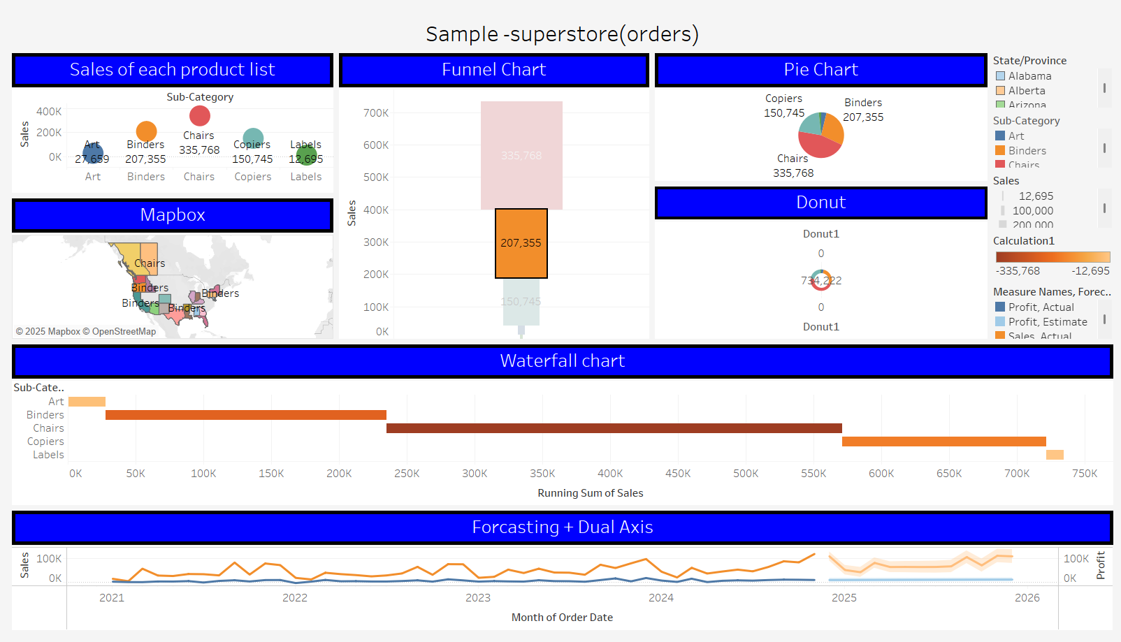

DashBoard -2 :

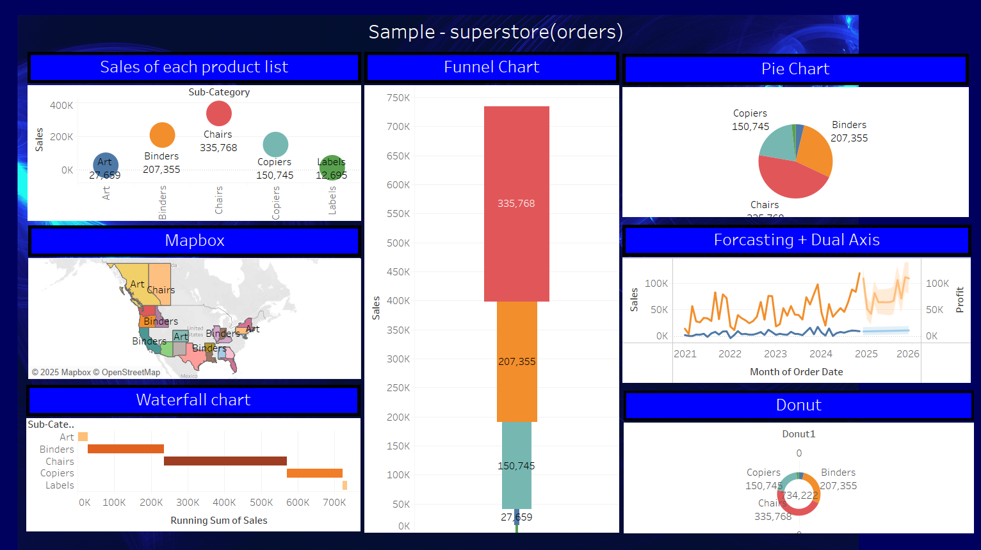

DashBoard -3 :

